**Basic Commands**

**forward(distance) -** *Moves forward in the direction the turtle is facing the distance that you enter.*

**left(degrees), right(degrees) -** *Rotates the turtle left or right the number of degrees you enter. A turn is based on the direction the turtle is facing.*

**seth(degrees) -** *Sets the direction the turtle is facing based on the coordinate circle directions.*

**color(‘color’) -** *Changes the turtle color to the color you enter. Ex. ‘blue’, ‘black’, ‘light blue’*

**Advanced Commands**

**speed(speed)** – *Sets the speed that the turtle moves. 1=slowest, 11=fastest.*

**circle(radius) -** *Draws a circle with the radius that you enter.*

**setposition(x-coordinate, y-coordinate) -** *Moves the turtle to the (x,y) coordinate you specify. Envision the canvas is a coordinate plane with the center being (0,0).*

**up(), down() -** *When the turtle is down and moves it draws a line behind it. When the turtle is up nothing will be drawn when it moves.*

**pensize(width)** – Sets the width of the line drawn by the turtle

**shape(‘shape’)** – Sets the shape of the turtle. Ex. ‘turtle’, ‘classic’, ‘arrow’, ‘square’, ‘circle’

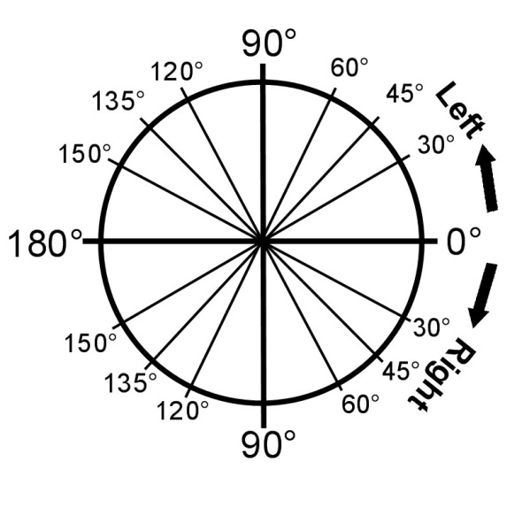

**Copying Files**

*Open V-Assignments*

*Open TechEd*

*Move this window to the right slightly (using the blue bar at the top of the window).*

*Go to the ZENworks window again*

*Open MyDocuments*

*Open your TechEd folder*

*Move this window to the left slightly.*

*Drag the Python folder from the Assignments into your TechEd folder*

*Close the Assignments folder*

*In the V:Assignments TechEd folder*

*Double click Idle(Python.GUI)*

*Click Open*

**Opening a File**

*Open the Python folder in your TechEd folder*

*Right click on practice*

*Select ‘Edit with Idle’*

**Saving a File**

*In the Idle window go to File->Save OR hit ctrl+s*

**Running a File**

*In the Idle window go to Run->Run Module OR hit F5*